|  |
| --- |
| Crafty Cuts Laser |
| Backup and Recovery |
| Version 1.1 |

|  |
| --- |
| Jack Irving, Fiona Huang and Nasser Al-Oqayli  2-4-2016 |

# Introduction

This guide is meant to assist our client with creating backups and recovering the system in the event something goes wrong. Instructions have already been provided in the user manual however they will be provided here again to help make it clearer and direct.

# Backups and restores

First the admin must go to the hoopla (hosting company) website as shown in the first image below. As of the time of writing this document that’s Hoopla found at <https://www.hooplahosting.com/>. Then click on the Client Area button in the top right hand corner of the site. The admin will be prompted for their log in credentials, these were provided to the client via an email by Hoopla and can be found in the Initial System Access Instructions document.

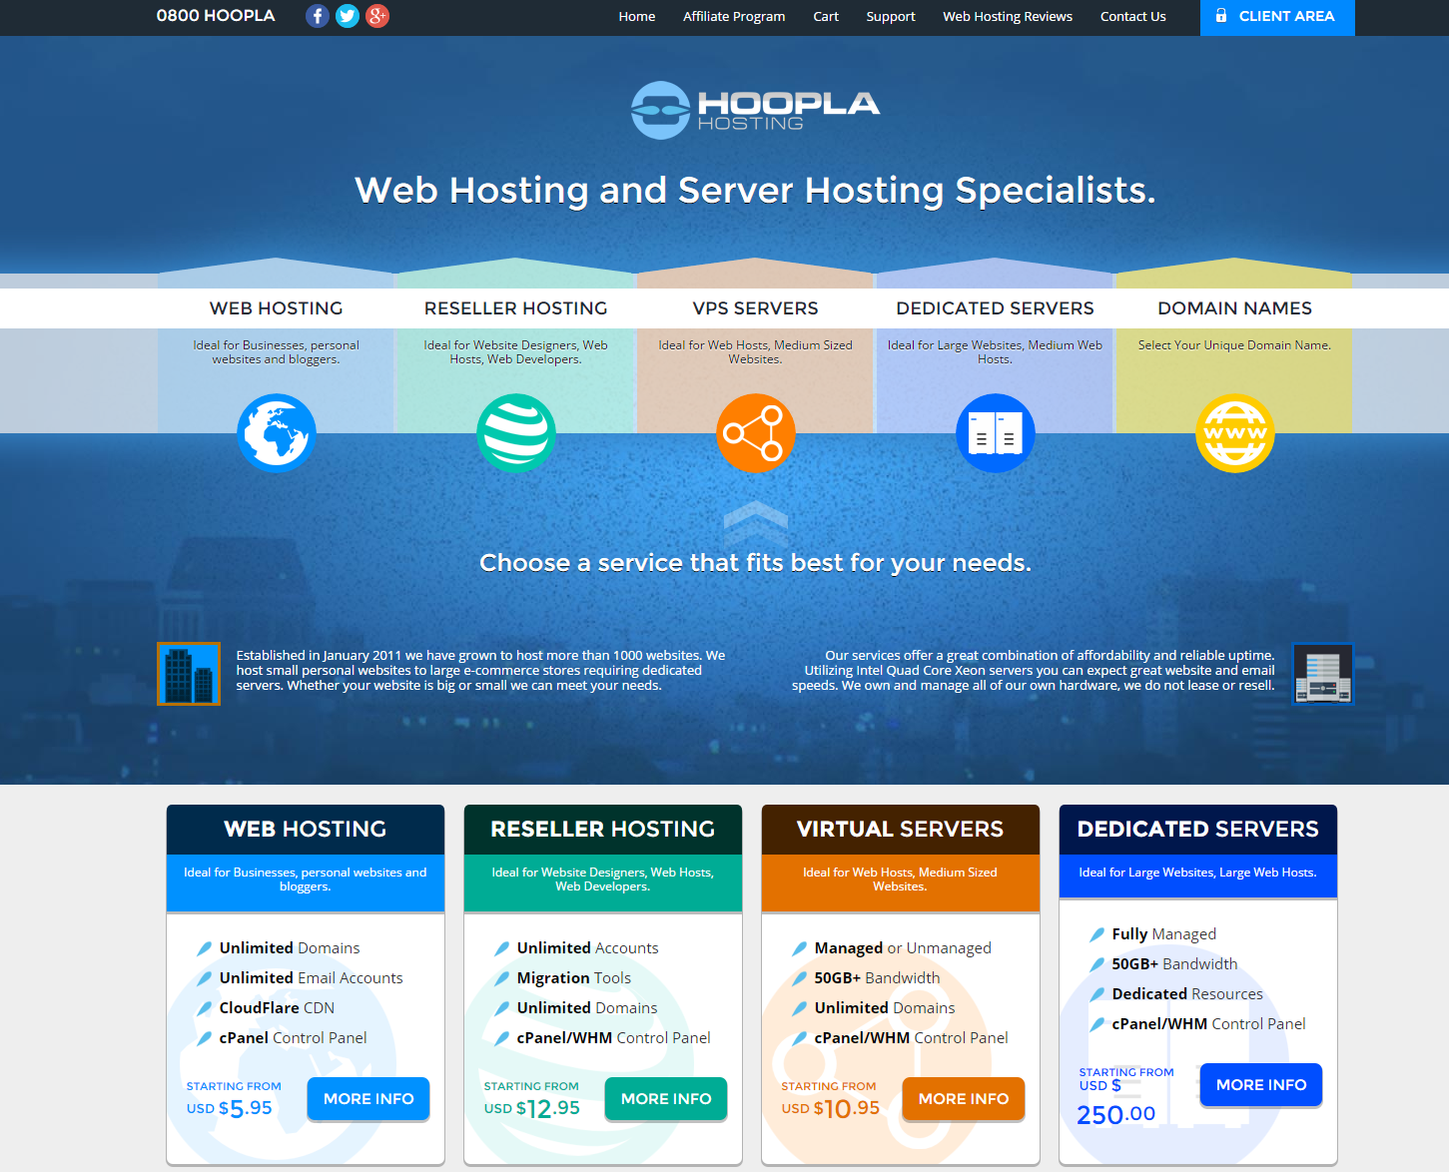

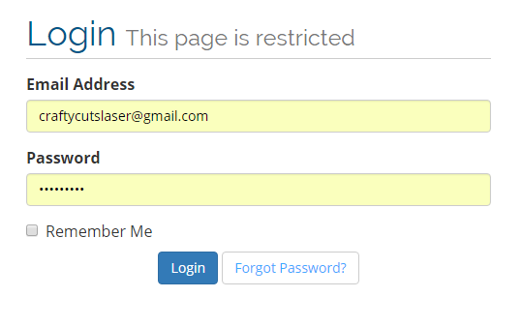

Once logged in the admin, navigates to their services, clicking on the listing and not the link to the website. From here they can select Login to CPanel, they won’t require log in credentials here however if they’ve timed out they’ll need to log in again. The login credentials specifically for Crafty Cuts Laser CPanel is provided in the initial system access documentation.

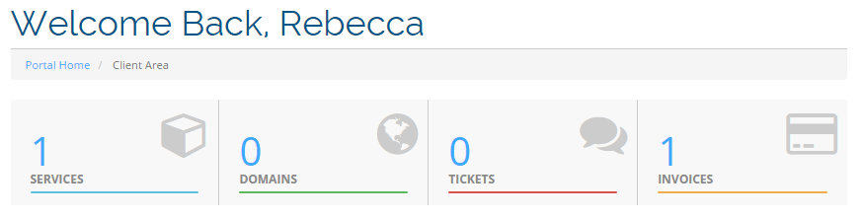

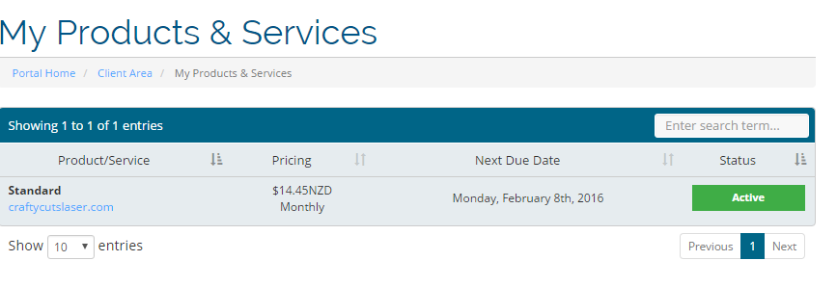

From the CPanel the admin scrolls toward the bottom of the page and selects something called Softulous App Installer. From here they are able to select Backups and Restores from the menu in the top right hand corner and are then presented with options to restore or create a new backup. 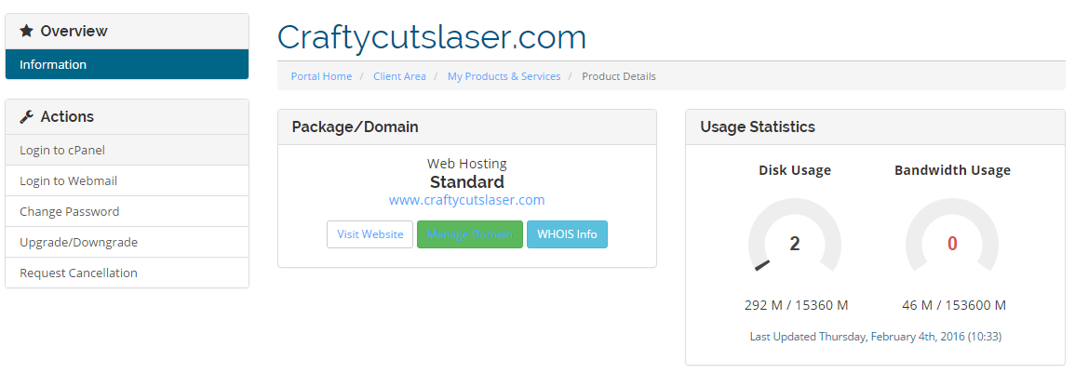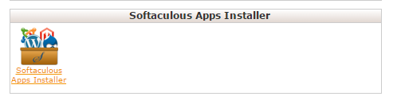

Backups are dated by the date they were created and will continue for 10 days of automated backups before the oldest is written over by a new backup. In the event that something has malfunctioned and the system needs to be restored. Pressing the blue button will restore the system to that save.

